**Onboarding OCI to sentinel via Azure Functions.**

1. Get Data Connector Installed,
2. Tell OCI admin person to follow below steps to generate API key.,(The same steps available in Data connector Page) .. In the Next Step use the Below Workspace ID and Primary Key.

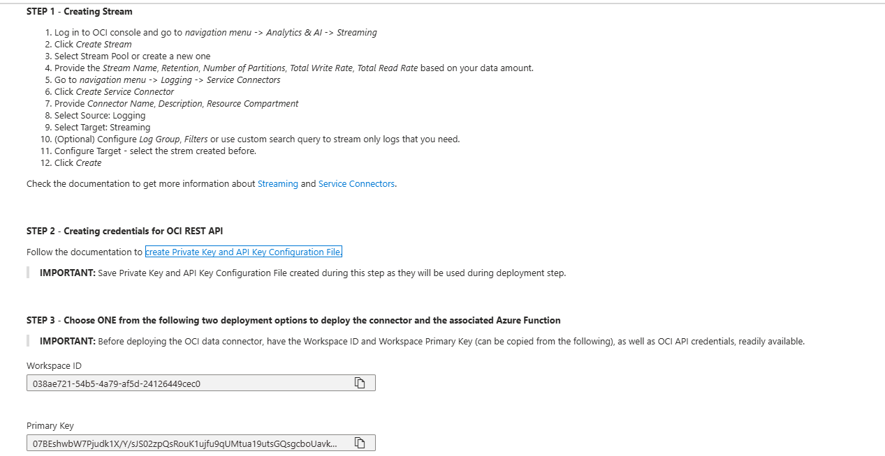

1. Now from Option 1, click on Deploy To Azure,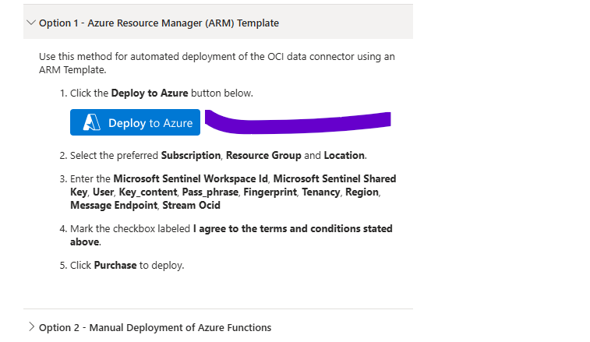
2. Now here fill all the details below.

Here, under User tab we need to fill user detail who is generating private key…Instead depending on that person, we can tell them to create a Service account and provide all necessary permission to OCI portal and use that service account details under User field.

The mandatory is, Fingerprint, Private Key from OCI portal and all other details must and should be given by OCI team.

Note: Whatever region you are selecting, get above values from same region, then only it will work like if you are taking private key from one region and fingerprint from one region that doesn’t work.,

App Insights Workspace Resource ID: For this one, go to to particular log analytics workspace, under overview, go to Json View and their will get it as below.,

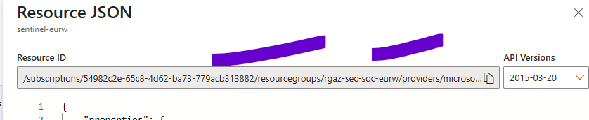

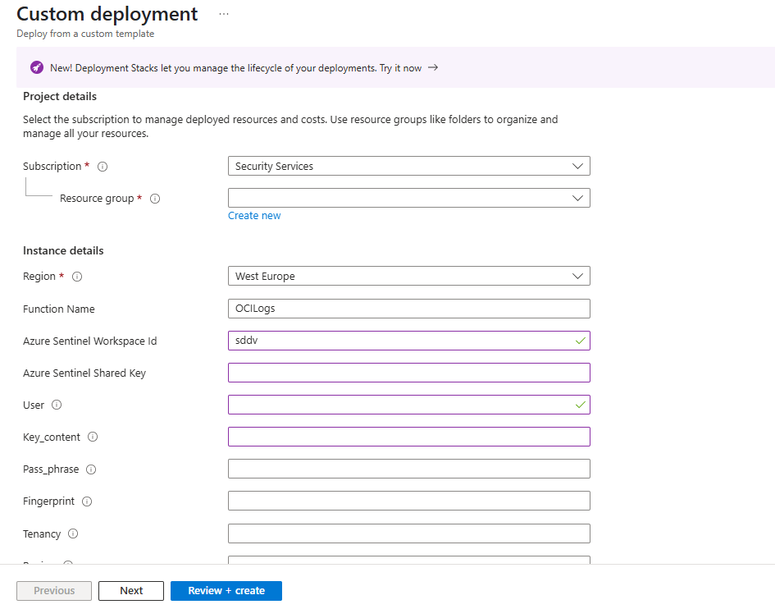

1. Once done click review and create. After this a Function app will get created with name starting **OCI,**
2. **Now go to Function app, and click on** [**AzureFunctionOCILogs**](https://portal.azure.com/#blade/WebsitesExtension/FunctionTabMenuBlade/resourceId/%2Fsubscriptions%2F54982c2e-65c8-4d62-ba73-779acb313882%2FresourceGroups%2Frgaz-sec-soc-eurw%2Fproviders%2FMicrosoft.Web%2Fsites%2Focilogsxjr6e4dhnf6we%2Ffunctions%2FAzureFunctionOCILogs) **tab.**

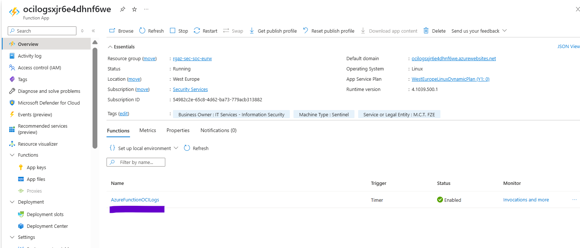

1. Here Under **Invocations**, we can see whether we are getting logs or any error with the function App.,

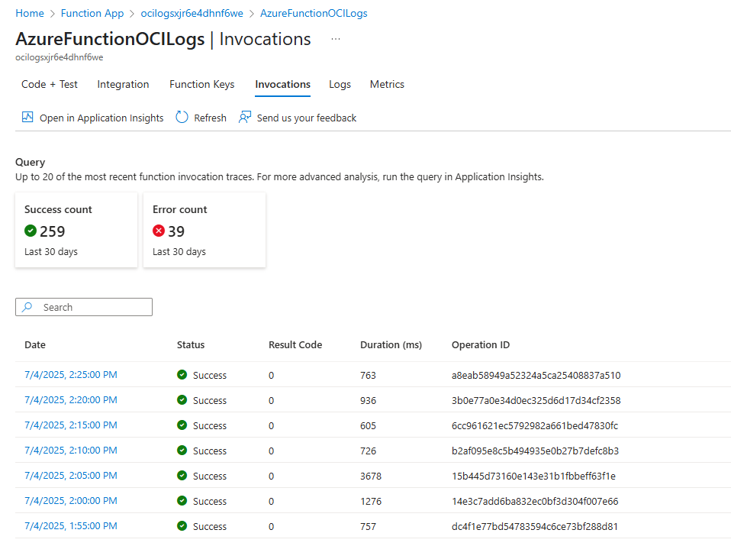

1. In future if we encounter any log ingestion issue, the basic troubleshooting we can do is restart the function App.
2. So after complete deployment, if we see Error count or log ingestion is not happening, then we might have provided some wrong values at the time of deployment, so if we get that right value after deployment, under Function App, search for Environment variables, here click on Advanced Edit, whatever value is incorrect edit here and save it.

